Pokhara University

Level: Bachelor | Semester – Fall | Year : 2009
Programme: BE |  | Full Marks : 100
Course: Soil Mechanics |  | Time : 3hrs.

Candidates are required to give their answers in their own words as far as practicable.
The figures in the margin indicate full marks.

Attempt all the questions.

1. | - What are the different soil classification systems? Explain the Textural type of classification.  - Prove that the degree of saturation of a partially saturated soil can be expressed as  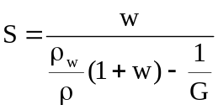 | 7  8
2. | - What are the types of Consolidation? Explain the method of determination of coefficient of permeability by Square root of time fitting method.  - The consolidation settlement of a new structure founded on a 5 m. thick layer is estimated as 6.5 cm. the structure was observed to have settled by 1.6 cm in six months after the completion of construction. If the clay layer is underlain by rock &overlain by a layer of coarse sand, Determine:  - The time required for 50% consolidation.  - The amount of settlement which will take place in the next six months. | 7  8
3. | - Define the terms: Steady flow, flow nets and uplift pressure. What are the criteria of design of filters? Explain.  - A sand deposit consists of two layers. The top layer is 3.0m thick (ρ = 17 kN/m³) and the bottom layer is 4m thick (ρ_{sat} = 21 kN/m³). The water table is at a depth of 4 m from the surface and the zone of capillary saturation is 1m above the water table. Draw the diagrams, showing the variation of total stress, neutral stress and effective stress. | 7  8
4. | - Describe the direct shear test. What are its merits and demerits?  - A homogeneous earthen Dam 30 m. high has free board of 1.5 m. A flow net was constructed & the following results were noted.  No. of potential drops: 12  No. of flow channels: 03  The dam has a 18m.long horizontal filter at its downstream end. Calculate the seepage loss across the dam per day, if the width of the dam is 200m & the coeff. of permeability of the soil is 3.35x 10⁻⁴cm /sec. | 7  8
5. | - In order to determine the average coefficient of permeability of a bed of sand 14 meters thick, overlying on impermeable stratum, a well was sunk through the sand and a pumping test was carried out. After a certain interval the discharge was 12.4 liters per second and draw down in the observation wells at 16meters and 33 meters respectively, from the pumping well were found to be 1.787 m and 1.495 m respectively. If the GWT was originally 2.14 m below the ground surface, find (a) the permeability of sand layers and (b) an approximate value for the effective grain sizes.  - A slope inclined at 16 degree to the horizontal is to be made in a cohesionless deposit having the following properties.  G = 2.70, e = 0.72, Ø = 35⁰  Determine the factor of safety of the slope against shear failure if water percolates in a direction parallel to the surface of the slope. | 7  8
6. | - What are the various lab-test for the determination of shear strength of soil. Explain the method of Direct shear test.  - Using Fadum’s chart, determine the increase in the vertical stress at 2 m depth below A and B due to uniformly distributed load of 40 kN/m² on the ground surface shown by the area in the figure 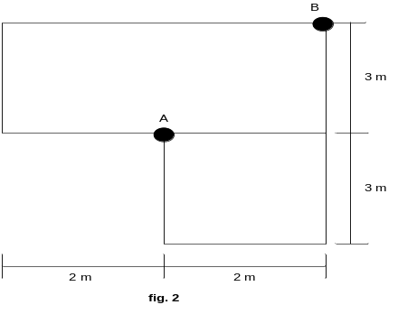 | 7  8
7. | Write short notes on (Any two)  - Terzaghis theory of one dimensional Consolidation.  - Quick sand condition caused and remedies.  - Optimum moisture content | 5×2

